Law Of Demand

Economics Research Paper

By: Siddharth Pandya

Rollno: A023

Demand in economics is the consumer's desire and ability to purchase a good or service. It's the underlying force that drives economic growth and expansion. Without demand, no business would ever bother producing anything.

**Introduction to the Law of Demand:**

The law of demand expresses a relationship between the quantity demanded and its price. It may be defined in Marshall’s words as **“the amount demanded increases with a fall in price, and diminishes with a rise in price”.** Thus it expresses an inverse relation between price and demand. The law refers to the direction in which quantity demanded changes with a change in price.

On the figure, it is represented by the slope of the demand curve which is normally negative throughout its length. The inverse price- demand relationship is based on other things remaining equal. This phrase points towards certain im­portant assumptions on which this law is based.

#### Assumptions of the Law of Demand:

**These assumptions are:**

(i) There is no change in the tastes and preferences of the consumer;

(ii) The income of the consumer remains constant;

(iii) There is no change in customs;

(iv) The commodity to be used should not confer distinction on the consumer;

(v) There should not be any substitutes of the commodity;

(vi) There should not be any change in the prices of other products;

(vii) There should not be any possibility of change in the price of the product being used;

(viii) There should not be any change in the quality of the product; and

(ix) The habits of the consumers should remain unchanged. Given these conditions, the law of demand operates. If there is change even in one of these conditions, it will stop operating.

Given these assumptions, the law of demand is explained in terms of Table 3 and Figure 7.

**[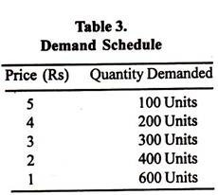](http://cdn.economicsdiscussion.net/wp-content/uploads/2016/08/clip_image016_thumb2.jpg)**

**[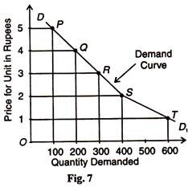](http://cdn.economicsdiscussion.net/wp-content/uploads/2016/08/clip_image018_thumb2.jpg)**

The above table shows that when the price of say, orange, is Rs. 5 per unit, 100 units are de­manded. If the price falls to Rs.4, the demand increases to 200 units. Similarly, when the price declines to Re.1, the demand increases to 600 units. On the contrary, as the price increases from Re. 1, the demand continues to decline from 600 units.

In the figure, point P of the demand curve DD1 shows demand for 100 units at the Rs. 5. As the price falls to Rs. 4, Rs. 3, Rs. 2 and Re. 1, the demand rises to 200, 300, 400 and 600 units respectively. This is clear from points Q, R, S, and T. Thus, the demand curve DD1 shows increase in demand of orange when its price falls. This indicates the inverse relation between price and demand.

#### Exceptions to the Law of Demand:

In certain cases, the demand curve slopes up from left to right, i.e., it has a positive slope. Under certain circumstances, consumers buy more when the price of a commodity rises, and less when price falls, as shown by the D curve in Figure 8. Many causes are attributed to an upward sloping demand curve.

**[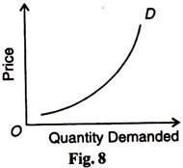](http://cdn.economicsdiscussion.net/wp-content/uploads/2016/08/clip_image020_thumb2.jpg)**

**(i) War:**

If shortage is feared in anticipation of war, people may start buying for building stocks or for hoarding even when the price rises.

**(ii) Depression:**

During a depression, the prices of commodities are very low and the demand for them is also less. This is because of the lack of purchasing power with consumers.

**(iii) Giffen Paradox:**

If a commodity happens to be a necessity of life like wheat and its price goes up, consumers are forced to curtail the consumption of more expensive foods like meat and fish, and wheat being still the cheapest food they will consume more of it. The Marshallian example is applicable to developed economies.

In the case of an underdeveloped economy, with the fall in the price of an inferior commodity like maize, consumers will start consuming more of the superior commodity like wheat. As a result, the demand for maize will fall. This is what Marshall called the Giffen Paradox which makes the demand curve to have a positive slope.

**(iv) Demonstration Effect:**

If consumers are affected by the principle of conspicuous consump­tion or demonstration effect, they will like to buy more of those commodities which confer distinction on the possessor, when their prices rise. On the other hand, with the fall in the prices of such articles, their demand falls, as is the case with diamonds.

**(v) Ignorance Effect:**

Consumers buy more at a higher price under the influence of the “igno­rance effect”, where a commodity may be mistaken for some other commodity, due to deceptive packing, label, etc.

**(vi) Speculation:**

Marshall mentions speculation as one of the important exceptions to the down­ward sloping demand curve. According to him, the law of demand does not apply to the demand in a campaign between groups of speculators. When a group unloads a great quantity of a thing on to the market, the price falls and the other group begins buying it. When it has raised the price of the thing, it arranges to sell a great deal quietly. Thus when price rises, demand also increases.

**(vii) Necessities of Life:**

Normally, the law of demand does not apply on necessities of life such as food, cloth etc. Even the price of these goods increases, the consumer does not reduce their demand. Rather, he purchases them even the prices of these goods increase often by reducing the demand for comfortable goods. This is also a reason that the demand curve slopes upwards to the right.

## **Demand Curve**

If you were to plot out how many units you would buy at different prices, then you've created a [demand curve](https://www.thebalance.com/demand-curve-definition-types-and-how-it-works-3305705). It graphically portrays the data that's been detailed in a demand schedule.

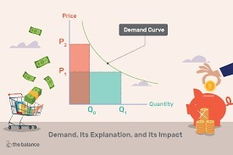

In the chart above, price is on the x-axis and quantity bought is on the y-axis. At P2, the higher price, people will only buy Q0, the lower quantity. If the price drops to P1, then the quantity bought will increase to Q1.

When the demand curve is relatively flat, then people will buy a lot more even if the price changes a little. When the demand curve is fairly steep, then the quantity demanded doesn't change much, even though the price does.

## **Elasticity of Demand**

Demand elasticity means how much more, or less, demand changes when the price does. It's specifically measured as a ratio. It's the percentage change of the quantity demanded divided by the percentage change in price.

There are three levels of demand elasticity:

1. Unit elastic is when demand changes by the exact same percentage as the price does.
2. [Elastic](https://www.thebalance.com/elastic-demand-definition-formula-curve-examples-3305836) is when demand changes by a greater percentage than the price does.
3. [Inelastic](https://www.thebalance.com/inelastic-demand-definition-formula-curve-examples-3305935) is when demand changes by a smaller percentage than the price does.

## **Aggregate Demand**

[Aggregate demand](https://www.thebalance.com/aggregate-demand-definition-formula-components-3305703), or market demand, is the demand from a group of people. The five determinants of individual demand govern it. There’s also a sixth: the number of buyers in the market.

Aggregate demand can be measured for a country. It's the quantity of the goods or services the country produces that the world's population demands. For that reason, it is composed of the same five components that make up [gross domestic product](https://www.thebalance.com/what-is-gdp-definition-of-gross-domestic-product-3306038):

1. [Consumer spending](https://www.thebalance.com/consumer-spending-definition-and-determinants-3305917).
2. Business investment spending.
3. [Government spending](https://www.thebalance.com/current-u-s-federal-government-spending-3305763).
4. [Exports](https://www.thebalance.com/exports-definition-examples-effect-on-economy-3305838).
5. [Imports](https://www.thebalance.com/imports-definition-examples-effect-on-economy-3305851), which are subtracted from aggregate demand and GDP.

## **Businesses Depend on Demand**

All businesses try to understand and guide consumer demand. They seek to understand it with market research. They attempt to guide it with marketing, including public relations and advertising.

Companies with a [competitive advantage](https://www.thebalance.com/what-is-competitive-advantage-3-strategies-that-work-3305828) draw more demand. One advantage is to be the low-cost provider. For example, Costco provides bulk purchases with low prices per unit. Another is to be the most innovative. Apple charges higher prices because they are the first to the market with new products.

If something is in high demand, businesses make more revenue. If they can't make more fast enough, the price goes up. If the price increase sustains over time, then you have inflation.

If demand drops, then businesses will lower prices. They hope that's enough to shift demand from their competitors and take more market share. If that doesn't work, they will innovate and create a better product. If demand still doesn't rebound, then companies will produce less and lay off workers. If that happens across the board, it can cause an [economic contraction](https://www.thebalance.com/economic-contraction-4067683). That phase of the [business cycle](https://www.thebalance.com/what-is-the-business-cycle-3305912) creates a [recession](https://www.thebalance.com/what-is-a-recession-3306019).

## **Demand and Fiscal Policy**

The federal government also tries to manage demand to prevent either inflation or recession. This ideal situation is called the [Goldilocks economy](https://www.thebalance.com/goldilocks-economy-definition-causes-effects-3305932).

Policymakers use [fiscal policy](https://www.thebalance.com/what-is-fiscal-policy-types-objectives-and-tools-3305844) to boost demand in a recession or lowers it during inflation. To boost demand, it either cuts taxes or purchases more goods and services. It can also give [subsidies](https://www.thebalance.com/government-subsidies-definition-farm-oil-export-etc-3305788) to businesses or benefits to individuals such as [unemployment benefits](https://www.thebalance.com/government-subsidies-definition-farm-oil-export-etc-3305788). It increases demand by raising confidence and creating enough jobs. Research shows that the [best ways to create those jobs](https://www.thebalance.com/unemployment-solutions-3306211) is government spending on mass transit and education.

To lower demand, [Congress](https://www.thebalance.com/u-s-congress-definition-duties-effect-on-economy-3305980) can raise taxes, cut spending, or withdraw subsidies and benefits. This often angers beneficiaries and leads to the elected officials being booted out of office.

## **Demand and Monetary Policy**

Most inflation fighting is left to the [Federal Reserve](https://www.thebalance.com/the-federal-reserve-system-and-its-function-3306001) and [monetary policy](https://www.thebalance.com/what-is-monetary-policy-objectives-types-and-tools-3305867). The Fed's most effective tool for reducing demand is by raising [interest rates](https://www.thebalance.com/what-are-interest-rates-and-how-do-they-work-3305855). This shrinks the [money supply](https://www.thebalance.com/what-is-money-supply-3306128) and reduces lending. With less to spend, consumers and businesses might want more, but they have less money to do it with.

The Fed also has powerful tools to boost demand. It lowers interest rates and increases the money supply. With more money to spend, businesses and consumers can buy more.

Even the Fed is limited in boosting demand. If unemployment remains high for a long period of time, then consumers don't have the money to get the basic needs met. No amount of low interest rates can help them, because they can't take advantage of low-cost loans. They need jobs to provide income and confidence in the future. That's when Congress must step in with [expansionary fiscal policy](https://www.thebalance.com/expansionary-fiscal-policy-purpose-examples-how-it-works-3305792).

## **Materials and methods**

The method of the research was an experiment carried via an anonymous questionnaire, see Appendix A. The research was approved by the Ethical committee of the Silesian University in Opava. At the beginning of the experiment, respondents (university students) were addressed with the following words: “Please, fill the questionnaire related to one of our faculty projects”.

The instructor did not provide any other explanation or instructions to reduce acquiescence bias (“yes saying”) to a minimum.

In the questionnaire itself, respondents were asked about their age and gender, and then were shown a picture of a tablet (Samsung Galaxy Tab4 10.1VE SM-T533) with its specification. Ten questions of the type: “Would you buy this tablet for (6000, 5000, 4000, 3000, 2000, 1500, 1000, 500, 300 and 100) CZK” with “YES” or “NO” answers followed (23 CZK = 1 USD). Respondents answered “YES” or “NO” to the question with the highest price, and proceeded immediately to questions with lower prices in the descending order. The whole experiment lasted only several minutes. Due to simplicity and swiftness of the experiment the only bias that might occur was an indifference bias (some respondents may not care to fill the survey properly, though they were verbally motivated to do so).

At the time of the experiment, the tablet was offered for 7023 CZK at the biggest Czech Internet online wholesaler Heureka.cz. The research was carried out among students of two courses (Statistics and Mathematical methods in Economics) at School of Business Administration, Silesian University in Opava, in the Czech Republic, in 2016. Only fully answered questionnaires were processed. From individual demand functions the market demand function was constructed as their sum. The total number of respondents was 121; including 89 women and 32 men. As for respondents age, 27 respondents were aged under 21 and 94 respondents were 21 and older.

The experiment was repeated in 2019 in Ecuador at Universidad Central del Ecuador, Escuela Politécnica Nacional and Universidad Nacional de Chimborazo; and in Spain at Universidad de Córdoba, Universidad Rey Juan Carlos and others. The experiment was conducted via online questionnaire similar to the one in Appendix A, the only change being a currency involved (US dollars and Euros respectively). Again, respondents were university students. In Ecuador, 142 respondents (68 women and 74 men) participated in the study, while the sample in Spain consisted of 114 respondents (69 women and 45 men).

In addition to the experimental derivation of the market demand curves (functions) at three aforementioned locations, the following two null hypotheses H01 and H02 dealing with respondents’ rationality were tested by the chi-square test for independence.

•

H01: “There is no difference in rationality between men and women”.

•

H02: “There is no difference in rationality between younger and older students”.

The level of statistical significance α was set to be 0.01. All tables and figures thereinafter are made by the authors.

## **Results**

### **Results of the experiment – Czech Republic**

Results of the study in the form of the market demand are provided in [Table 1](https://www.sciencedirect.com/science/article/pii/S2405844019363455" \l "tbl1). [Fig. 2](https://www.sciencedirect.com/science/article/pii/S2405844019363455" \l "fig2) shows empirically derived market demand function and the inverse market demand function (the market demand function is not a function in terms of mathematical terminology in this case).

Table 1. Empirically derived data points of the demand curve (function), Czech Republic.

| **Price (CZK)** | **Quantity demanded** | **Price (CZK)** | **Quantity demanded** |
| --- | --- | --- | --- |
| 6 000 | 15 | 1 500 | 82 |
| 5 000 | 23 | 1 000 | 71 |
| 4 000 | 40 | 500 | 66 |
| 3 000 | 79 | 300 | 65 |
| 2 000 | 83 | 100 | 66 |

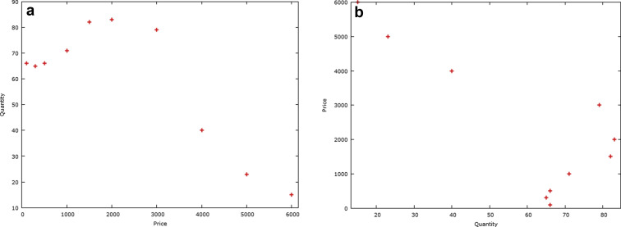

Fig. 2. a) Data points of the inverse of the demand function of the experiment. The Czech Republic, price in CZK. b) Data points of the demand curve of the experiment. The Czech Republic, price in CZK.

From the [Table 1](https://www.sciencedirect.com/science/article/pii/S2405844019363455#tbl1) and [Fig. 2](https://www.sciencedirect.com/science/article/pii/S2405844019363455#fig2) it's clear that the market demand is not monotonous. The data points suggest the demand is decreasing from 2,000 CZK to 6,000 CZK as expected by economic theory. However, between 100 CZK and 1,500 CZK the demand is increasing, and not decreasing as would the law of demand suggest. The turning point is 1,500 CZK. This point, the loss of confidence occurred, at the price of approximately 21% of the price offered by Heureka.cz online shop.

Respondents, who answered “YES” for a certain price, and also for all lower prices, were considered rational (as well as several respondents who answered “NO” to all prices). Out of 121 respondents, 58% respondents were rational and 42% respondents irrational (in terms of the experiment). Men were slightly more rational than women, while differences in rationality between younger students (under 21) and older students (21 and above) were smaller. Numbers of rational and irrational respondents with respect to their gender and age are provided in [Table 2](https://www.sciencedirect.com/science/article/pii/S2405844019363455" \l "tbl2).

Table 2. Numbers of rational and irrational respondents with respect to gender and age for the Czech Republic, Ecuador and Spain.

| **Respondents** | **Rational/Irrational CZE** | **Rational/Irrational ECU** | **Rational/Irrational ESP** |
| --- | --- | --- | --- |
| men | 21/11 | 47/27 | 34/11 |
| women | 49/40 | 22/46 | 33/36 |
| under age of 21 | 15/12 | 15/17 | 24/16 |
| 21 years and more | 55/39 | 54/56 | 43/31 |

Note: The number 21/11 in the second row and column means that 21 men from the Czech Republic were rational, and 11 men were irrational, and so on in the rest of the table.

At last, both null hypotheses from the previous section where evaluated:

•

H01: “There is no difference in rationality between men and women”.

The critical valueχ0.012(1)=6.6, test value G = 1.08; H01 cannot be rejected.

•

H02: “There is no difference in rationality between younger and older students”.

The critical valueχ0.012(1)=6.6, test value G = 0.075; H02 cannot be rejected.

Hence, in the case of respondents from the Czech Republic, the differences in rationality between men and women, and between younger and older students, were found statistically insignificant.

### Results of the experiment – Ecuador

The results of the experiment carried out among Ecuadorian undergraduate university students are presented in [Table 3](https://www.sciencedirect.com/science/article/pii/S2405844019363455" \l "tbl3) and [Fig. 3](https://www.sciencedirect.com/science/article/pii/S2405844019363455" \l "fig3)a, b. It can be seen that the market demand is not monotonically decreasing, and the loss of confidence effect appears at the turning point of 150 USD (at approximately 49% of the price of the product at retailer's website).

Table 3. Empirically derived data points of the demand curve (function), Ecuador.

| **Price (USD)** | **Quantity demanded** | **Price (USD)** | **Quantity demanded** |
| --- | --- | --- | --- |
| 250 | 18 | 100 | 70 |
| 230 | 21 | 70 | 57 |
| 200 | 43 | 50 | 62 |
| 180 | 52 | 30 | 61 |
| 150 | 76 | 20 | 67 |
| 120 | 67 |  |  |

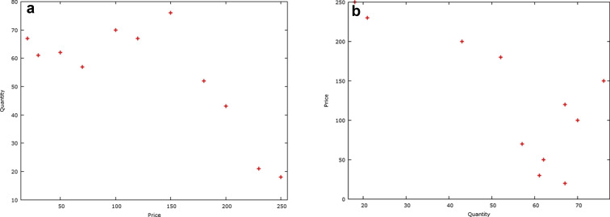

Fig. 3. a) Data points of the inverse of the demand function of the experiment. Ecuador, price in USD. b) Data points of the demand curve of the experiment. Ecuador, price in USD.

Out of 142 respondents, 49% respondents were rational and 51% respondents irrational. Men were more rational than women, see [Table 2](https://www.sciencedirect.com/science/article/pii/S2405844019363455#tbl2), while differences in rationality between younger students (under 21) and older students (21 and above) were negligible.

The null hypotheses were evaluated with the following results:

•

H01: The critical valueχ0.012(1)=6.6, test value G = 13.77; H01 was rejected.

•

H02: The critical valueχ0.012(1)=6.6, test value G = 0.049; H02 cannot be rejected.

Hence, the difference in rationality between men and women was found statistically significant at p = 0.01 level.

### Results of the experiment – Spain

The results of the experiment carried out among Spain undergraduate university students are presented in [Table 4](https://www.sciencedirect.com/science/article/pii/S2405844019363455" \l "tbl4) and [Fig. 4](https://www.sciencedirect.com/science/article/pii/S2405844019363455" \l "fig4)a, b. In analogy to results from the Czech Republic and Ecuador, the market demand is not monotonically decreasing, and the loss of confidence effect appears at the turning point of 120 Euros (at approximately 44% of the price of the product at retailer's website).

Table 4. Empirically derived demand curve (function), Spain.

| **Price (Euro)** | **Quantity demanded** | **Price (Euro)** | **Quantity demanded** |
| --- | --- | --- | --- |
| 250 | 29 | 100 | 76 |
| 230 | 36 | 70 | 69 |
| 200 | 53 | 50 | 67 |
| 180 | 60 | 30 | 65 |
| 150 | 74 | 20 | 66 |
| 120 | 73 |  |  |

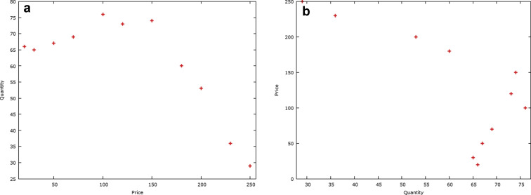

Fig. 4. a) Data points of the inverse of the demand function of the experiment. Spain, price in Euro. b) Data points of the demand function of the experiment. Spain, price in Euro.

Out of 114 respondents, 59% respondents were rational and 41% respondents irrational. Men were more rational than women again, see [Table 2](https://www.sciencedirect.com/science/article/pii/S2405844019363455#tbl2), while differences in rationality between younger students (under 21) and older students (21 and above) were much smaller.

The null hypotheses were evaluated with the following results:

•

H01: The critical valueχ0.012(1)=6.6, test value G = 8.64; H01 is rejected.

•

H02: The critical valueχ0.012(1)=6.6, test value G = 0.038; H02 cannot be rejected.

Hence, in case of Spanish respondents, the difference in rationality with respect to gender was found statistically significant at p = 0.01 level.

## Discussion

According to [Rabin (2013)](https://www.sciencedirect.com/science/article/pii/S2405844019363455" \l "bib25) or [Harstad and Selten (2013)](https://www.sciencedirect.com/science/article/pii/S2405844019363455" \l "bib13), little has been done to integrate insights of psychology on the limits of rationality into economics. The reason why the law of demand might not hold in its entire domains is that humans are not always totally rational ([Thaler and Sunstein, 2009](https://www.sciencedirect.com/science/article/pii/S2405844019363455" \l "bib29)). The literature on human cognitive bias and its effects on decision making is vast and growing quickly every year, see e.g. [Tversky and Kahneman (1974)](https://www.sciencedirect.com/science/article/pii/S2405844019363455" \l "bib31), [Kahneman (2011)](https://www.sciencedirect.com/science/article/pii/S2405844019363455" \l "bib18), [Dvorsky (2013)](https://www.sciencedirect.com/science/article/pii/S2405844019363455" \l "bib9), or [Munger (2015)](https://www.sciencedirect.com/science/article/pii/S2405844019363455" \l "bib23). [Ariely (2008)](https://www.sciencedirect.com/science/article/pii/S2405844019363455" \l "bib2) argues that when making a decision to buy certain good, an anchor price plays a vital role. The anchor price affects the way consumers perceive the value of a good hence forth, as they are comparing it to the anchor price.

The price of a product, when no other information about the product is available, provides signal about its quality, with the higher price obviously meaning the higher quality. Therefore, in such a situation, a low price product might be avoided by consumers due to is assumed inferior quality, and the law of demand becomes invalid. Though there is no paper in the scientific research questioning the law of demand validity known to authors, there is plenty of evidence of its invalidity for low prices coming from marketers and producers, see for example [Tuttle (2012)](https://www.sciencedirect.com/science/article/pii/S2405844019363455" \l "bib30), [D'Souza (2015)](https://www.sciencedirect.com/science/article/pii/S2405844019363455" \l "bib10), or [Clancy (2019)](https://www.sciencedirect.com/science/article/pii/S2405844019363455" \l "bib7). [Tuttle (2012)](https://www.sciencedirect.com/science/article/pii/S2405844019363455#bib30) explains that product's low price provides two conflicting messages to consumers: “It is a bargain”, and “It is a product of bad quality”, and these two messages compete across the set of consumers. Moreover, Tuttle specifically mentions 80% sales as a threshold that can discourage some consumers. [D'Souza (2015)](https://www.sciencedirect.com/science/article/pii/S2405844019363455#bib10) explains the role of the anchor price, when no other information is available, and how consumers might avoid too low-priced products. [Clancy (2019)](https://www.sciencedirect.com/science/article/pii/S2405844019363455#bib7) provides an example of marketing strategy based on a large sale that failed to attract customers. To summon, findings of the aforementioned marketing experts indicate that consumers prefer modest prices close to the anchoring price, and are not generally inclined towards “too low” prices.

Therefore, the result of the presented study can be, to some extent, explained by the existence of the aforementioned anchor price. Customers buying a certain good (or service) have their own expectations of an appropriate price based on their previous experience and knowledge (an anchor price, or reference price), or prices paid by other people. If the real price is close to their expectations, or slightly below it, they are likely to buy the product. A price significantly higher than an expected one will probably discourage from a purchase. On the other hand, much lower price might lead to customers’ confusion. Why is it so cheap? Does it have some flaws? Is it out of order? Is its quality acceptable? Generally, this situation occurs when a cognitive structure of an individual is in a conflict with reality.

That's why a large portion of respondents refused to buy the tablet for a price too low, though they had answered “YES” for a higher price for the same item already. This was verified by seven questionnaires that contained explanation of “NO” answer for the lowest prices. Respondents unanimously wrote: “The price is too low; it must be a piece of junk.”

It should be noted that the anchor price effect does not provide the sole explanation of our results, as in our experiment respondents were provided specification of the product and its color picture. The anchor price effect demonstrates itself particularly in cases when a price is the only signal of quality.

## Model

Based on empirical findings presented in the previous section, a new model of a market demand including the loss of confidence effect is proposed.

•

For rational consumers, the demand QR is described by monotonically decreasing function QR=f(P) as usual.

•

For less rational (irrational) consumers, the demand QI is described by a function that should reflect the loss of confidence effect. It can be assumed that the demand function attains its maximum QA when a price of a good is equal to an anchor price PA (the expected price by consumers), while the demand decreases with the increasing distance from the anchor price PA. Let us denote such function QI=g(P,PA).

Let α be the number of rational consumers, let β be the number of irrational consumers. Then the overall demand Q is given as the linear combination of both demands:(1)Q=αQR+βQI

[Fig. 5](https://www.sciencedirect.com/science/article/pii/S2405844019363455" \l "fig5) provides illustrative example of relation (1) when demand functions are linear and in the form of hyperbola. The line (a) corresponds to the standard decreasing market demand; the curve (b) reflects the loss of confidence effect and anchoring effect: it decreases with the growing distance to the anchor price PA. And finally, the curve (c) is a composition of (a) and (b) and corresponds to the situation when a market demand is generated by both rational and irrational consumers.

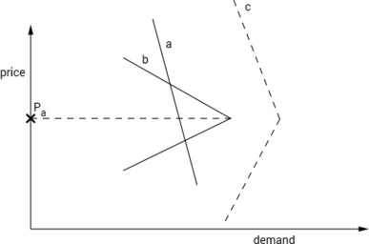

Fig. 5. A market demand generated by rational and irrational consumers. Source: authors. Note: the position of the curve (c) is only illustrative.

## **Conclusions**

The law of demand is a statement about the market demand curve, and this experiment provides only a new (simplified) model of real markets, therefore, its results should be considered with caution. The aim of this paper was to carry out an experiment in order to demonstrate that a demand function presented in microeconomics literature might not be decreasing in its entire domain due to the lower extent of rationality (or “limited rationality”) of some customers who distrust prices that are too low.

The presented research shows that some students are “imperfect economists”, or “humans” in Thaler's sense, in some situations, which could lead, along with the anchoring effect mentioned above, to violation of the law of demand in some situations.

The experiment was performed in three countries, the Czech Republic, Ecuador and Spain, with university students being respondents of the questionnaires. At all three locations the same effect of the loss of confidence was found, strongly suggesting that for prices perceived by respondents (consumers) to be too low (when compared to an anchor price), the law of demand might not be valid indeed. Due to the nature of the experiment, respondents provided their responses rather quickly, and it is known that “fast thinking” is susceptible to various kinds of cognitive biases, see e.g. [Kahneman (2011)](https://www.sciencedirect.com/science/article/pii/S2405844019363455" \l "bib18). Hence, it would be interesting to compare results with an experiment where respondents would take more time (thus involving the more logical “slow thinking”) for their answers.

Furthermore, the study revealed that around 45% of undergraduate students were not able to make rational decision even when facing an easy task such as buying a given product. In addition, statistically significant differences in rationality between men and women were found for respondents from Ecuador and Spain (but not for respondents from the Czech Republic).